**//Q1. C program to print the Fibonacci series using recursion.**

#include<stdio.h>

int fibo(int n)

{

if (n <= 1)

return n;

return fibo(n-1) + fibo(n-2);

}

int main (){

int n;

printf("Enter any number : ");

scanf("%d",&n);

for(int i=0; i<n; i++){

int fib = fibo(i);

printf("%d ", fib);

}

return 0;

}

**Output:**

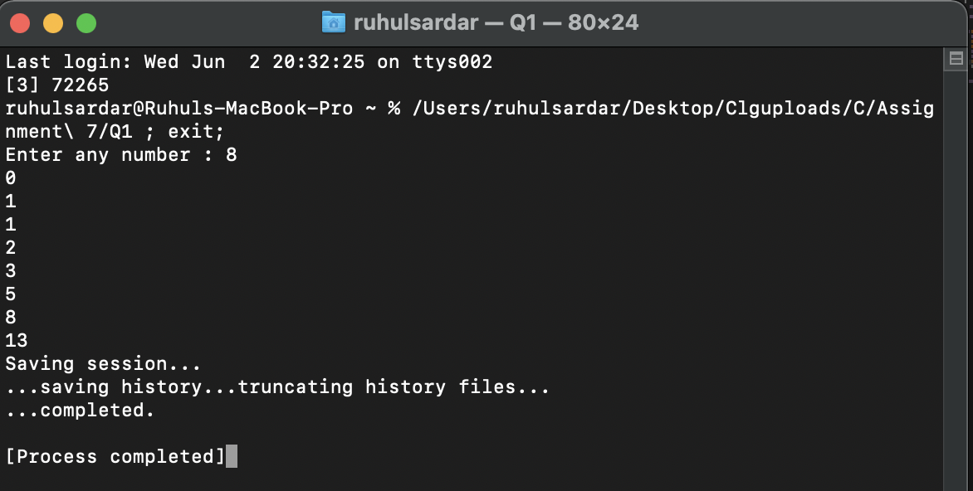

**//Q2. C program to print the factorial of a number using recursion.**

#include<stdio.h>

int fact(int n){

if(n<=1)

return 1;

return n*fact(n-1);

}

int main(){

int n;

printf("Enter the number which factorial is to be determined: ");

scanf("%d", &n);

int F = fact(n);

printf("The factorial of %d is %d", n,F);

return 0;

}

**Output:**

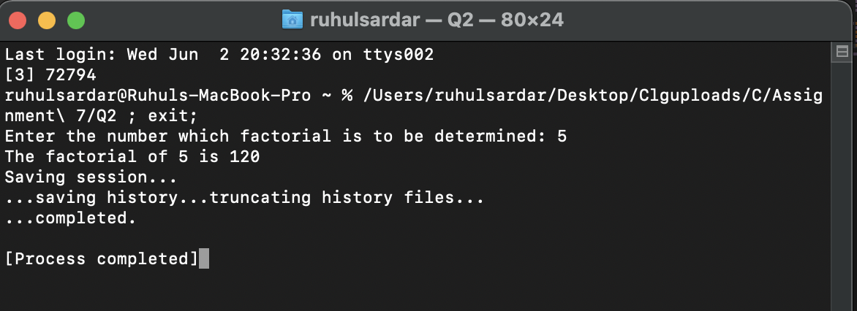

**//Q3. C program to print the non-Fibonacci series using recursion.**

#include<stdio.h>

int fib(int n){

if(n<=1)

return n;

return fib(n-1)+fib(n-2);

}

void nonFib(int n){

int fibn, fibm;

for(int i=0; i<n; i++){

fibn = fib(i);

fibm = fib(i+1);

for(int j=fibn+1; j<fibm; j++){

if(j<=n)

printf("%d ", j);

else

break;

}

}

}

int main(){

int n;

printf("Enter any number: ");

scanf("%d", &n);

nonFib(n);

return 0;

}

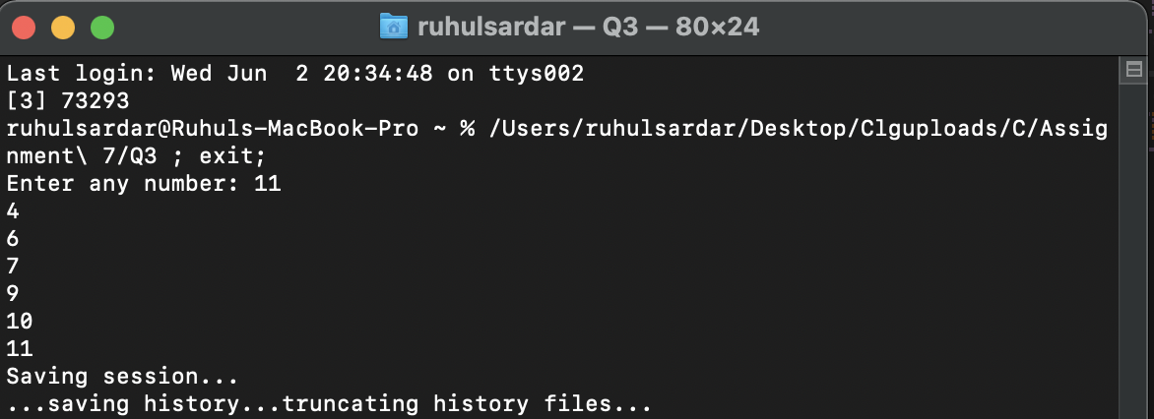**Output:**

**//Q4. C program to print the GCD of 2 numbers using recursion.**

#include<stdio.h>

#include<stdlib.h>

int gcd(int a, int b){

if(b==0)

return a;

return gcd(b,a%b);

}

int main(){

int x,y;

printf("Enter the 2 numbers: ");

scanf("%d%d", &x, &y);

int G = gcd(x,y);

printf("The gcd of %d and %d is : %d", x,y,G);

return 0;

}

**Output:**

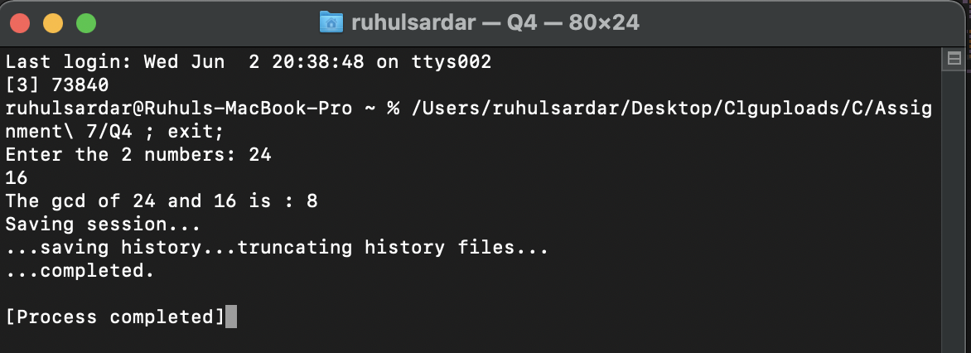

**//Q5. C program for Tower of Hanoi.**

#include<stdio.h>

void TOH(int n, char s, char d, char a){

if(n==1)

printf("\nMove from %c to %c", s,d);

else{

TOH(n-1,s,a,d);

printf("\nMove from %c to %c", s,d);

TOH(n-1,a,d,s);

}

}

int main(){

int n;

printf("Enter the number of discs: ");

scanf("%d", &n);

TOH(n,'A','C','B');

return 0;

}

**Output:**

